NIP Project — Submission Template
Pega Platform project · This document is your complete submission
Read this before you start:
1. Fill in Section 1 completely. The Pega application name must follow the format NIP-[Project]-[YourName].
2. Create a new Operator in Pega with your full name and log in as that operator before taking any screenshot.
3. When you create your test case, enter YOUR FULL NAME in the Issue Description (Vehicle) or Movie Name (Movie) field.
4. Complete only the section for your chosen project. Delete the other project section.
5. Paste one screenshot per user story (10 total). Follow the screenshot rules in your selected project section.
6. Answer every question in Sections 3 and 4 in your own words.
7. Save the file using this format: ProjectName_FirstName_LastName.docx. Use VehicleService or MovieTicket as the ProjectName. Examples: VehicleService_Ravi_Kumar.docx or MovieTicket_Ravi_Kumar.docx.

Section 1 — Your Details
Full Name | Tharun Kumar S
Email ID (registered on NIP) | tharun0062@gmail.com
Phone Number | 6379279702
College Name | V.S.B Engineering College
Course (e.g. IT, CS) | CSE
State | Tamil Nadu
Project Chosen (Vehicle Service OR Movie Ticket Booking) | Vehicle Service
Pega Application Name (e.g. NIP-VehicleService-YourName) | NIP-VehicleService-Tharun Kumar
Case Type Name (exact) | Vehicle Service Management
Pega Instance URL | https://kw8mwpco.pegacea.net/prweb/app/tk-vehicle-service-management/
Operator Name (created in Pega with your full name) | Tharun Kumar S

Section 2A — Vehicle Service Management Application
Complete this section only if you selected this project. Delete the other project section before submitting.

Screenshot rules — IMPORTANT before you start:
1. Name your Pega application as: NIP-VehicleService-YourName OR NIP-MovieTicket-YourName
2. Create a new Operator in Pega with your full name (Security → Operators) and log in as that operator.
3. When you create your test case, enter YOUR FULL NAME in the Issue Description (Vehicle) or Movie Name (Movie) field.
4. The logged-in operator name must be visible in every screenshot wherever the Pega interface displays it.
5. The student's full name must be visible in all running-case screenshots.
6. Configuration screenshots must clearly show the relevant application or rule name.
Screenshots that do not show these will not be accepted.

US-001 — Submit Vehicle Service Request
What is expected:
Case created, customer submits Vehicle ID, Vehicle Model, Issue Description. Validation applied.
Screenshot — paste your screenshot below this line:
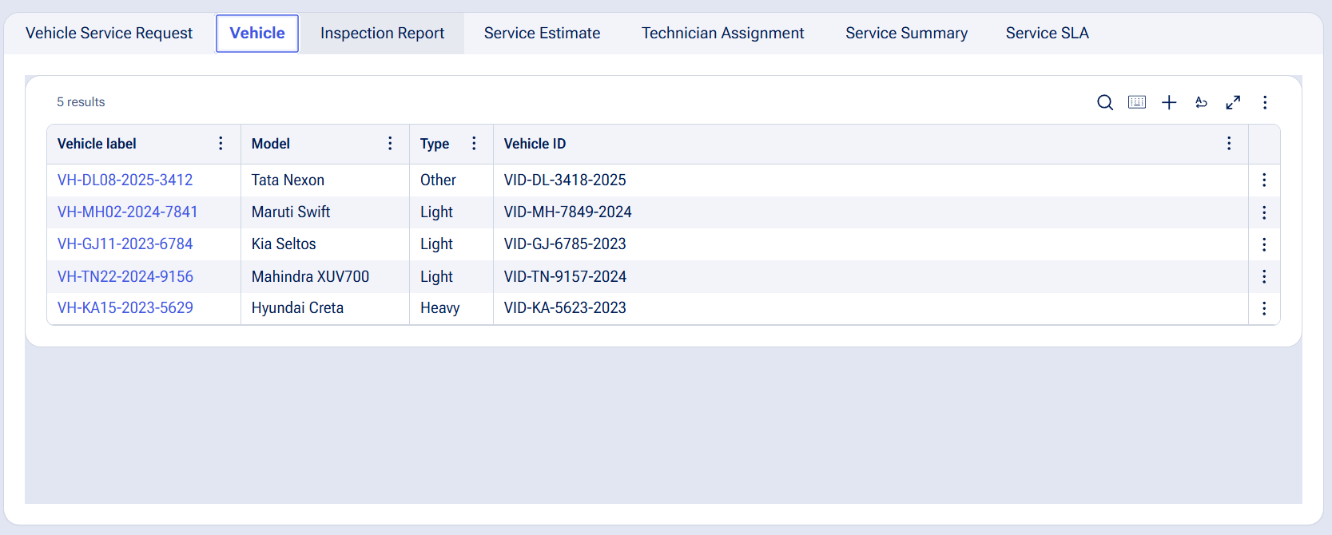

What I built for this (1–2 lines in your own words):
Built a Vehicle Service Request case where customers can submit Vehicle ID, Vehicle Model, and Issue Description. Added validation to ensure the submitted vehicle details are captured correctly.

US-002 — Perform Vehicle Inspection
What is expected:
Inspection stage with Service Advisor step. Inspection Notes and Condition Rating captured.
Screenshot — paste your screenshot below this line:
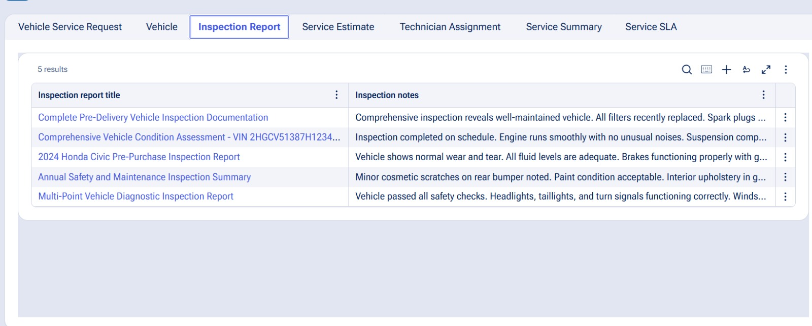

What I built for this (1–2 lines in your own words):
Built the Vehicle Inspection stage to capture inspection details and record the vehicle’s condition. Added inspection notes and documentation to support the service process.

US-003 — Generate Service Estimate
What is expected:
Labor Cost and Parts Cost captured. Total Cost calculated automatically by declare expression.
Screenshot — paste your screenshot below this line:
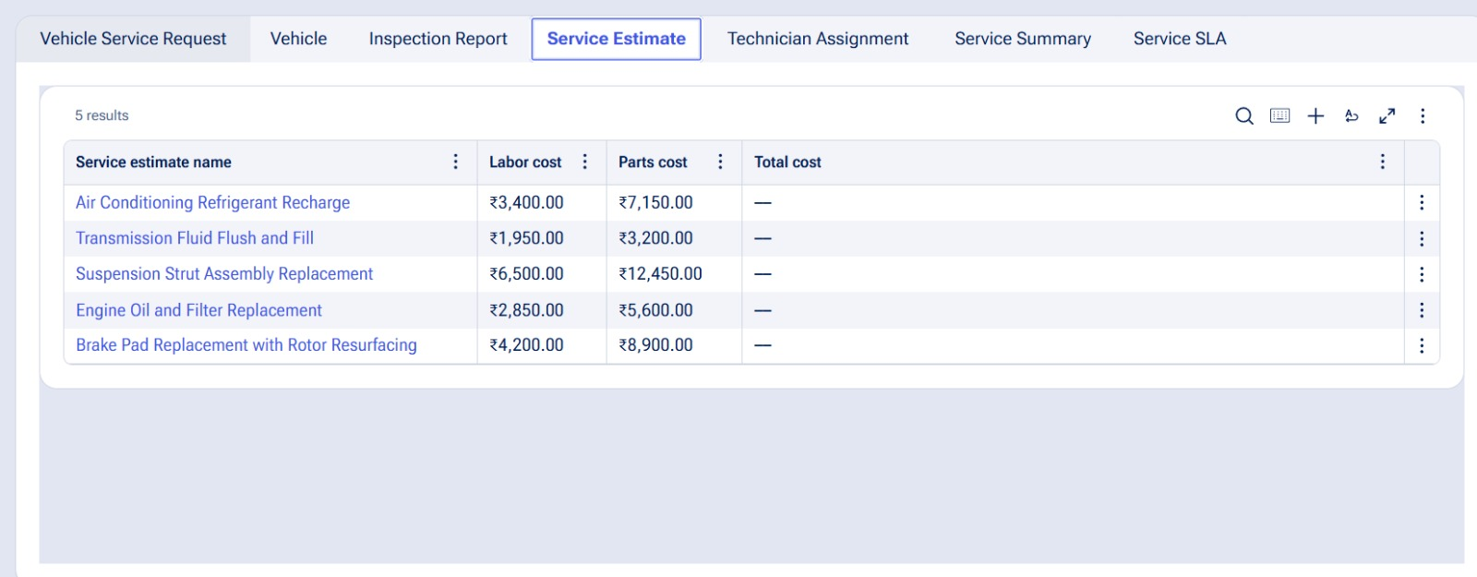

What I built for this (1–2 lines in your own words):
Built the Service Estimate stage to capture labor and parts costs. Configured the Total Cost to be calculated automatically using a declare expression

US-004 — Approve Service Estimate
What is expected:
Approval stage assigned to Customer. Approval Status captured. Flow branches on approve/reject.
Screenshot — paste your screenshot below this line:
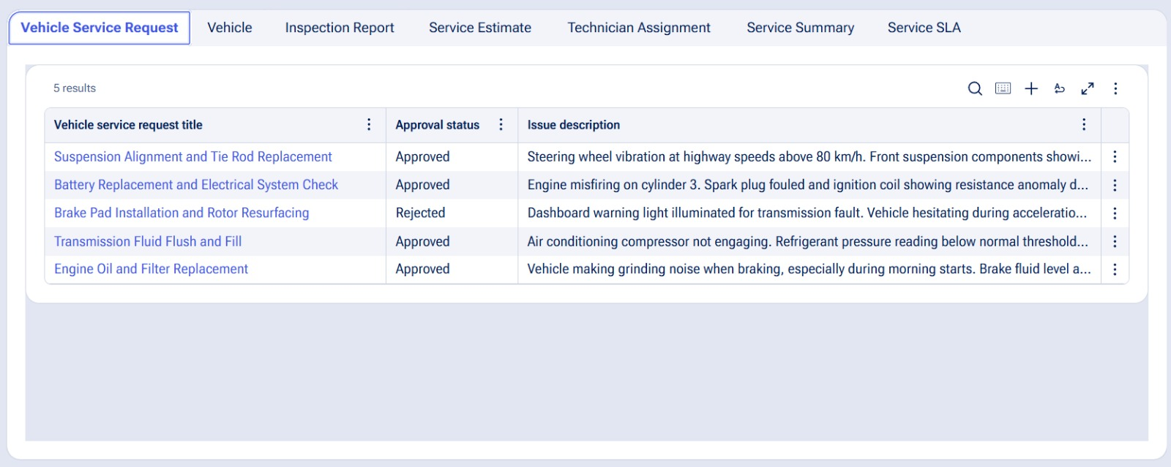

What I built for this (1–2 lines in your own words):
Built the Service Estimate approval stage and assigned it to the Customer. Captured the Approval Status and configured the flow to branch based on approve or reject

US-005 — Maintain Vehicle Data
What is expected:
Reusable Vehicle data object created with Vehicle ID, Model, Type — linked to case.
Screenshot — paste your screenshot below this line:
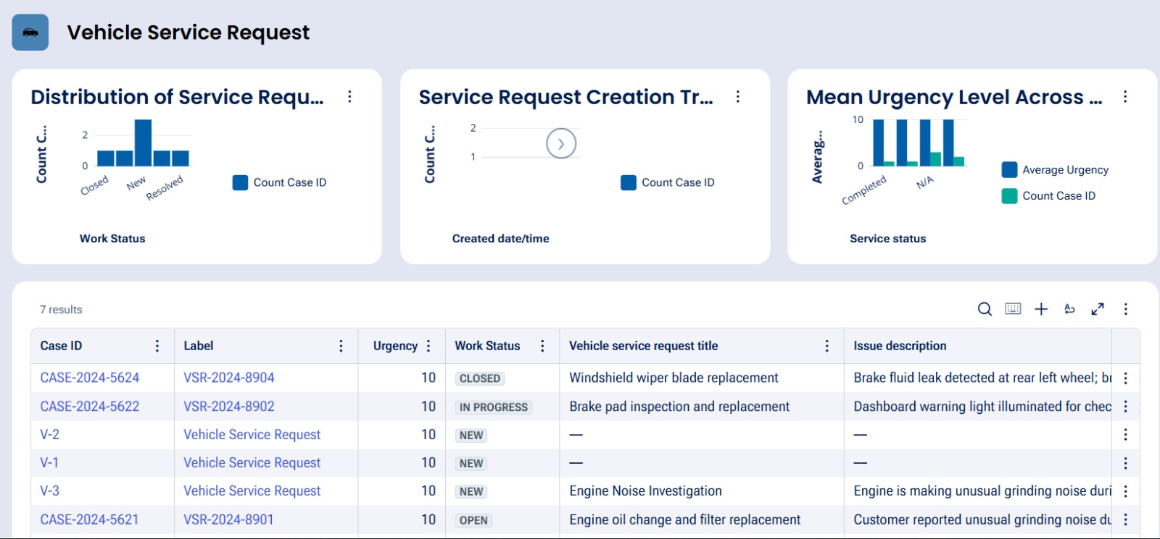

What I built for this (1–2 lines in your own words):
Created a reusable Vehicle data object with Vehicle ID, Model, and Type, and linked it to the Vehicle Service Request case

US-006 — Review Service Estimate
What is expected:
Approval screen shows Labor Cost, Parts Cost and Total Cost clearly to the Customer persona.
Screenshot — paste your screenshot below this line:


What I built for this (1–2 lines in your own words):
Created a reusable Vehicle data object with Vehicle ID, Model, and Type, and linked it to the Vehicle Service Request case

US-007 — Auto Assign Technician
What is expected:
Service Execution stage with routing to HeavyVehicleQueue or LightVehicleQueue. Assigned Technician and Service Status properties maintained.
Screenshot — paste your screenshot below this line:
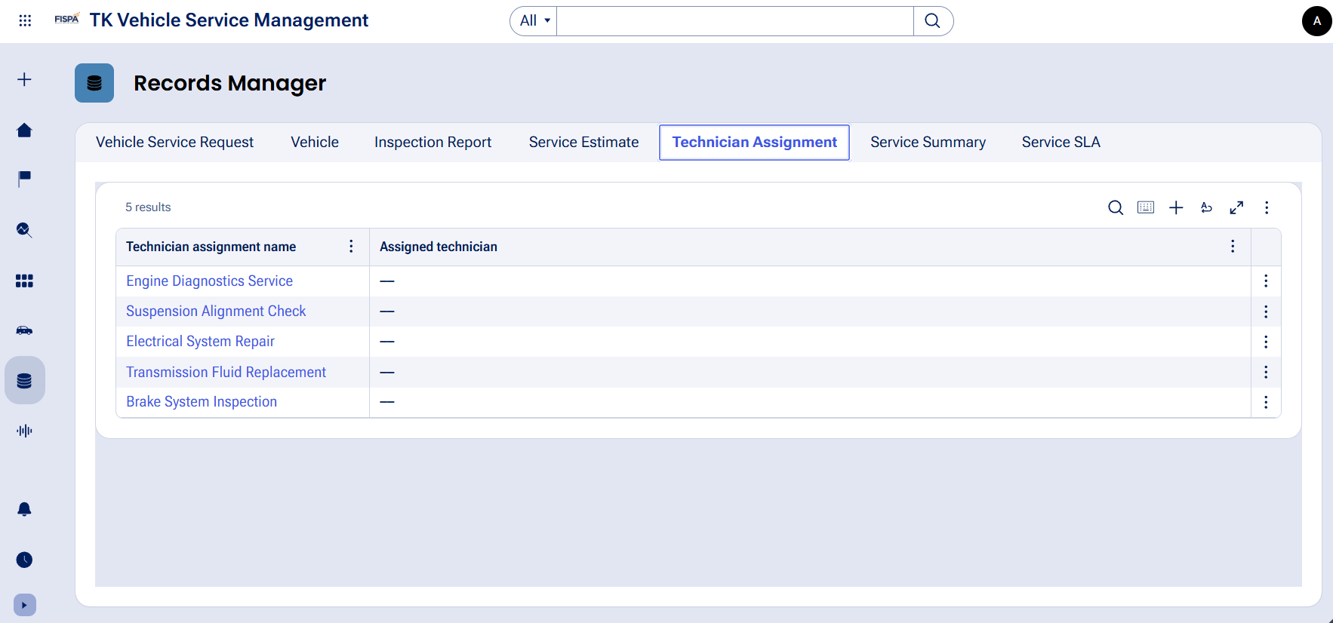

What I built for this (1–2 lines in your own words):
Configured automatic technician assignment with routing based on vehicle type and maintained the Assigned Technician and Service Status properties

US-008 — Notify Service Completion
What is expected:
Correspondence rule created and triggered on case resolution. Email includes case and vehicle details.
Screenshot — paste your screenshot below this line:
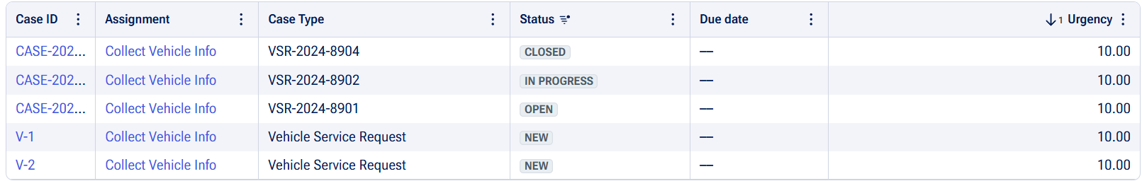

What I built for this (1–2 lines in your own words):
Created a correspondence rule that is triggered when the service case is resolved and sends an email containing the case and vehicle details

US-009 — Define Service SLA
What is expected:
SLA configured on the case type. Goal: 2 days. Deadline: 3 days. Priority increases on breach.
Screenshot — paste your screenshot below this line:
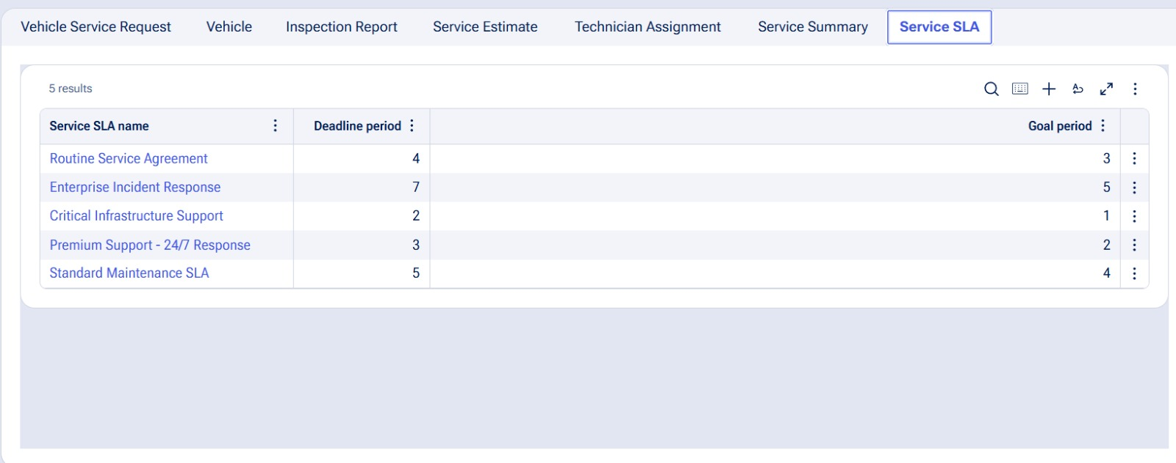

What I built for this (1–2 lines in your own words):
Configured the Service SLA with a 2-day goal and 3-day deadline, with priority increasing when the SLA is breached

US-010 — Route by Vehicle Type
What is expected:
Routing rule or Decision Table routes to HeavyVehicleQueue or LightVehicleQueue based on Vehicle Type property.
Screenshot — paste your screenshot below this line:
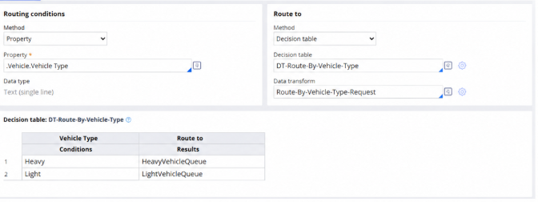

What I built for this (1–2 lines in your own words):
Configured a routing rule to route vehicles to the HeavyVehicleQueue or LightVehicleQueue based on the Vehicle Type property

Section 3 — About Your Application
These answers are checked against your screenshots. Write exactly what is in your application.

Q1. List your stages in the order they appear in your case lifecycle.
Stage names in order, separated by commas.
Submit Request, Inspection, Approval, Service Execution, Completion

Q2. Name the data object(s) you created and the properties inside them.
Data object name and its properties.
Vehicle — Vehicle ID, Model, Type

Q3. What is the exact name and type of the rule you used to calculate Total Cost?
Provide:
• Rule Name
• Rule Type
• Properties used in the calculation
• Formula used
Total Cost = Labor Cost + Parts Cost

Section 4 — Your Understanding
Short, honest and specific answers score well.

Q4. What did Blueprint generate for you, and what did you add or change yourself afterwards?
Be specific about what was already there and what you built or modified on top.
Blueprint generated the initial Vehicle Service Request case flow, stages, and basic data structure. I then configured the vehicle data, cost calculation, customer approval, vehicle-type routing, technician assignment, SLA, and service completion notification

Q5. Was there anything Blueprint created that you had to correct or configure further? Describe one example.
A real example from your own work.
Yes. I had to configure the vehicle-type routing further so that Heavy vehicles are routed to HeavyVehicleQueue and Light vehicles are routed to LightVehicleQueue using a Decision Table

Q6. Explain your case flow from creation to resolution, in order.
What happens first, who does what, when the case closes.
The customer creates a Vehicle Service Request and provides the vehicle and issue details. The vehicle is inspected, a service estimate is prepared with labor and parts costs, and the customer approves or rejects the estimate. If approved, the case proceeds to service execution with technician assignment and vehicle-type routing. After the service is completed, the case is resolved and a completion notification is sent

Q7. Pick two design choices you made in your application and explain why you made them.
For each design choice, provide:
• What you implemented
• Why you chose that approach
• What benefit it provides to the application
1. I used a reusable Vehicle data object with Vehicle ID, Model, and Type so vehicle information can be maintained consistently and reused across cases.
2. I used a Decision Table for vehicle-type routing so Heavy and Light vehicles are automatically sent to the appropriate work queue, making the routing easier to maintain

Q8. What was the hardest part, and how exactly did you fix it?
Specific and honest. A real challenge scores much better than a generic answer.
The hardest part was configuring the vehicle-type routing correctly. I fixed it by using Vehicle Type as the routing condition and configuring a Decision Table with Heavy routed to HeavyVehicleQueue and Light routed to LightVehicleQueue

Q9. If the approval step was only needed when Total Cost is above a certain amount, what would you change in your application?
Explain what you would change and where. You do not need to build this.
I would add a condition before the Approval stage to check the Total Cost. If Total Cost is above the specified amount, the case would proceed to Customer Approval; otherwise, it would skip the Approval stage and continue directly to Service Execution

Q10. List three exact rule names from your application that you personally created or modified.
Include the rule name and rule type for each one (for example: CalculateTotalCost - Declare Expression).
• a Declare Expression for Total Cost
• a routing rule/Decision Table for Vehicle Type
• a correspondence rule for service completion

Q11. List all personas used in your application.
List the persona names exactly as they appear in your application.
Customer, Service Advisor, Technician

Q12. List all work queues used in your application and explain when each one is used.
For each work queue, provide its exact name and the condition or type of work routed to it.
HeavyVehicleQueue — used for Heavy vehicles
LightVehicleQueue — used for Light vehicles
Before You Submit — Check These
Read through once before uploading.
1. Section 1 filled in. Application named as NIP-[Project]-[YourName]. Names match the actual application.
2. New Operator created in Pega with my full name. I logged in as that operator for all screenshots.
3. Only my chosen project section remains — the other project section is deleted.
4. All 10 user story screenshots are pasted and follow the operator, running-case, application, and rule-name evidence requirements.
5. Every question in Sections 3 and 4, including Q10, Q11, and Q12, is answered in my own words.
6. This file is named using the required format: ProjectName_FirstName_LastName.docx (for example, VehicleService_Ravi_Kumar.docx or MovieTicket_Ravi_Kumar.docx) and uploaded as required.

